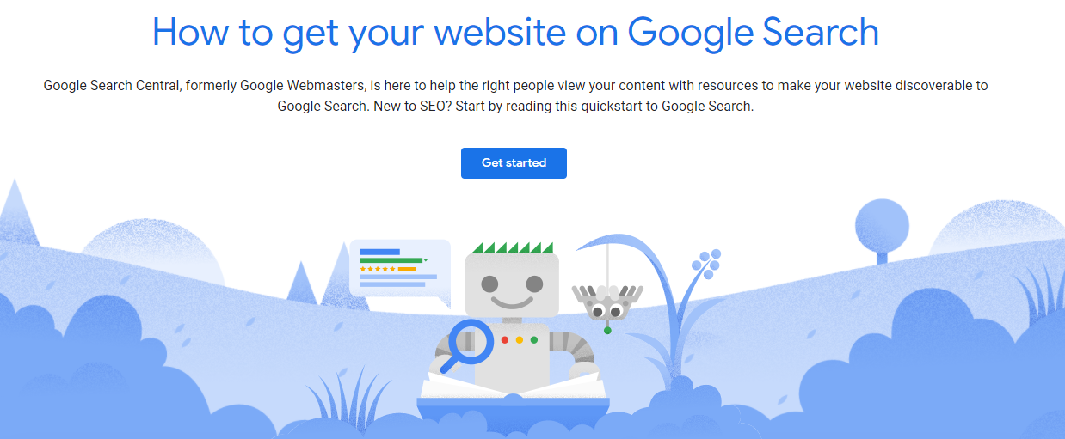

# Guide-Setup Google Search Console

## Web Application Development COP3834

## Professor Navarro

1. To the url <https://developers.google.com/search> and sign in with a google account
2. This site has documentation on various aspects of SEO from Google’s standpoint. This is a very useful resource since Google does not explicitly state the details of their search algorithms.
3. Click on Get Started under Developer.

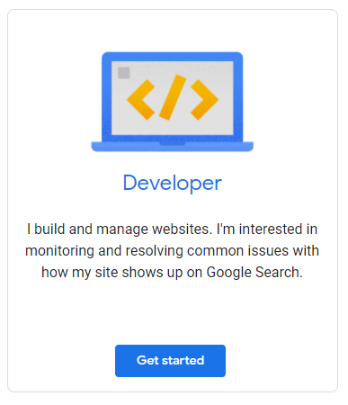

1. Click on Go to Search Console button or <https://search.google.com/search-console/welcome>

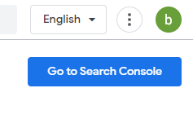

1. Add your domain to search console. 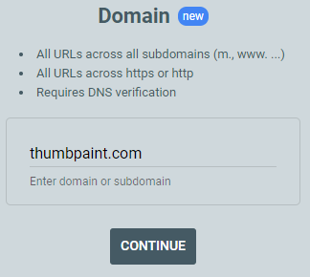
2. Verify domain ownership by adding TXT record to DNS configuration on Amazon Route 53.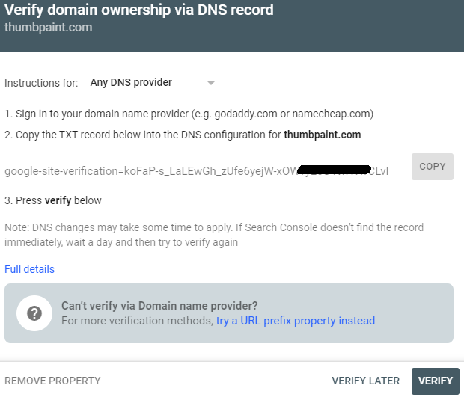
3. Log into your AWS Management Console. Select All Services.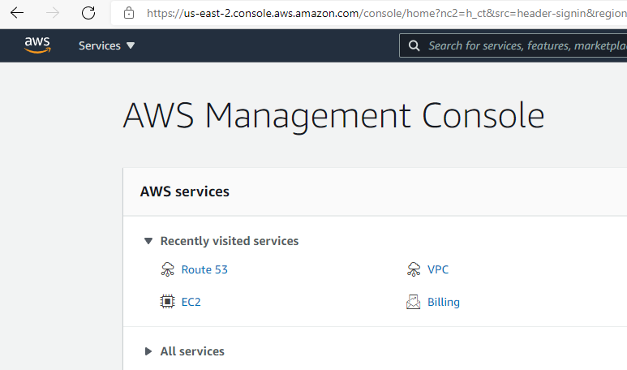
4. Select Route 53 in AWS Services. You can also use the search box at top. 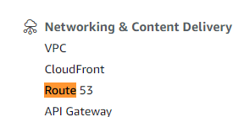
5. Click on “Hosted Zone” in Route 53 Dashboard. 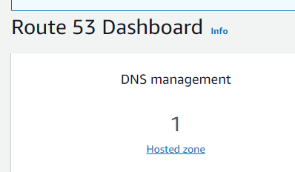
6. Select the domain name that you already added.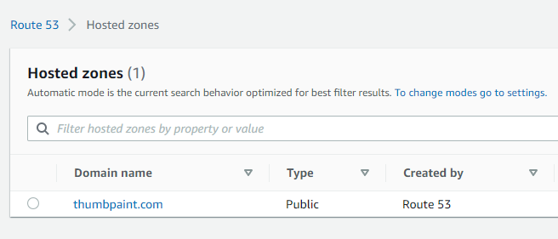
7. Click Create Record to add the TXT record from Google Search Console.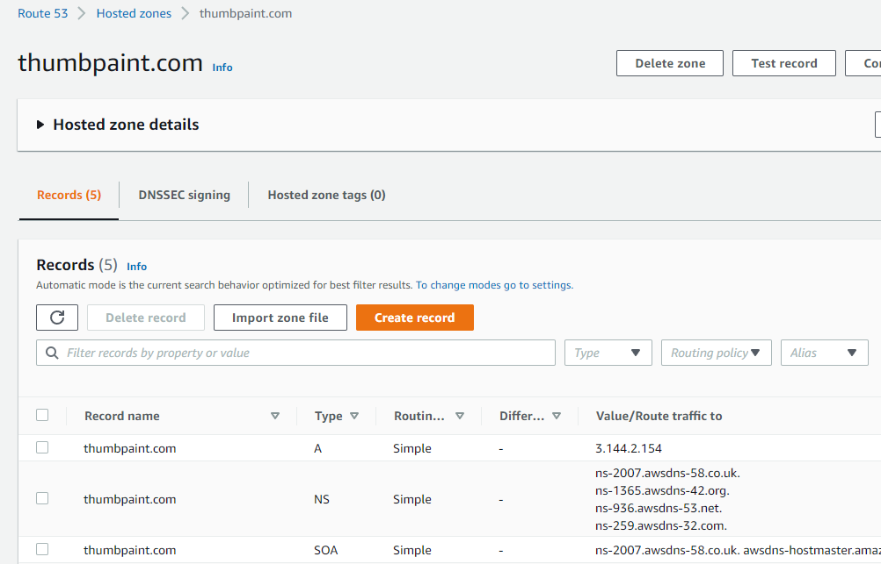
8. Set Record Type to “TXT”, then paste TXT record from Google Search Console in step #6 into “Value Field” followed by Create records button. 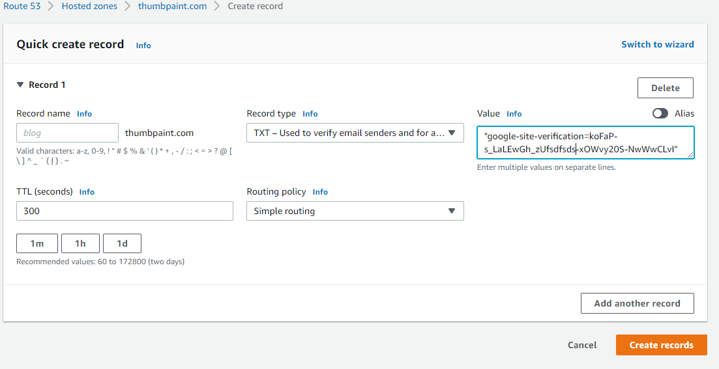
9. Your DNS records should be similar (but not exact) to the below. 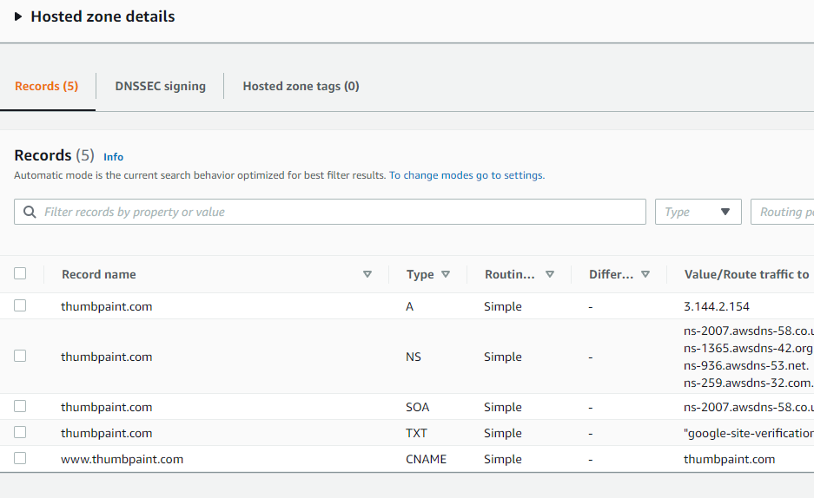
10. Check your new TXT record at DNS checker. Does it appear? [https://dnschecker.org/all-dns-records-of-domain.php](https://dnschecker.org/all-dns-records-of-domain.php)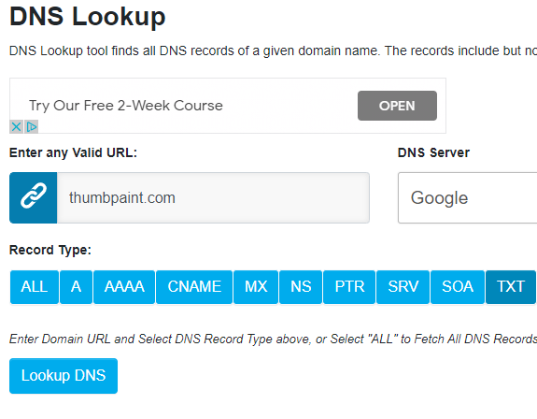 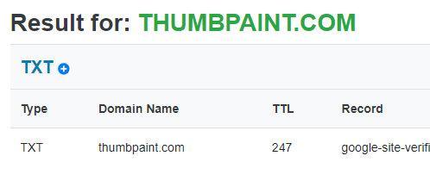
11. If your TXT record shows up in the DNS checker, click Verify on the Google Search Console Verify Domain tool . 
12. *If Ownership Verification Failed*, you can wait to complete the step, or click Verify Later. You will still need to verify the TXT record before you can proceed. 
13. If successful, Google will announce your property (domain) has been added to Search Console. 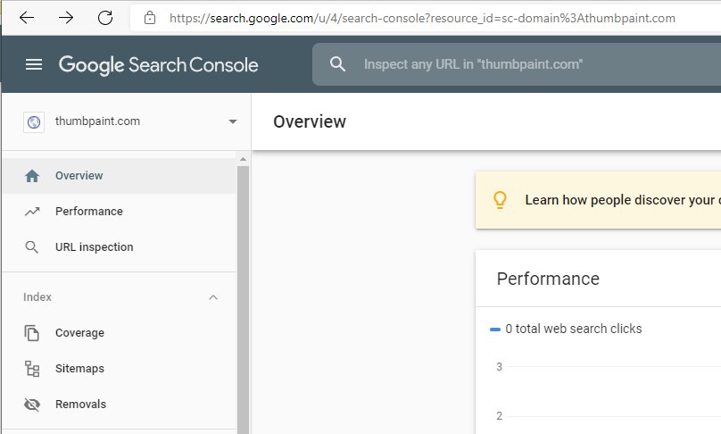
14. Click on sitemaps in Search console to add sitemap 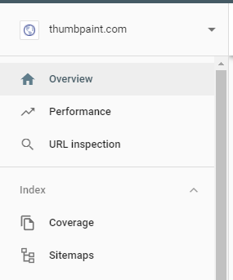
15. Type in the name of your sitemap and click “Submit”. Correct any errors in the sitemap if errors show up under “Status”. 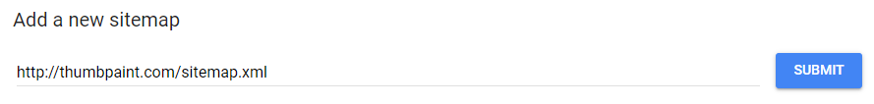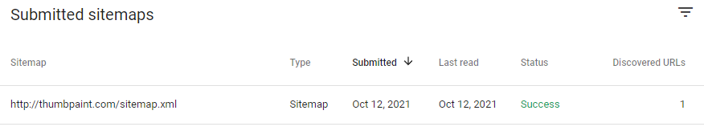
16. Check Performance tab in Google Search Console. This is where you will monitor search results. Initially it will show zero (0) clicks. 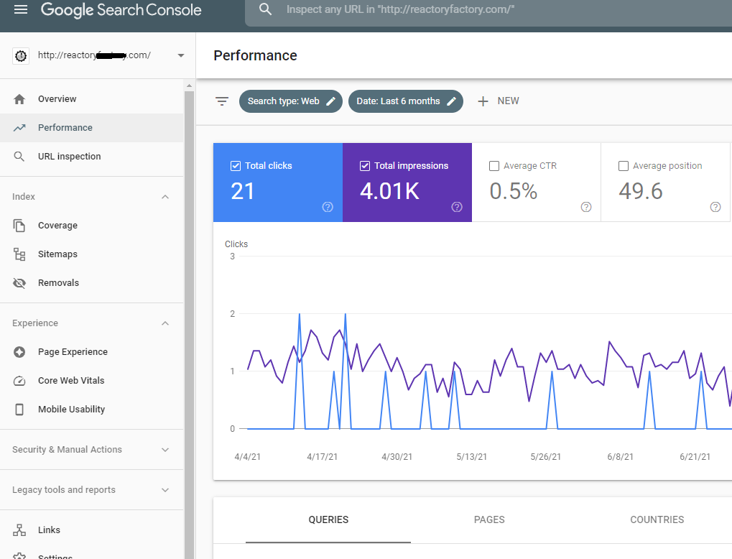
17. All team members to be able to view search results. Add each team member per [Google instructions](https://support.google.com/webmasters/answer/7687615): 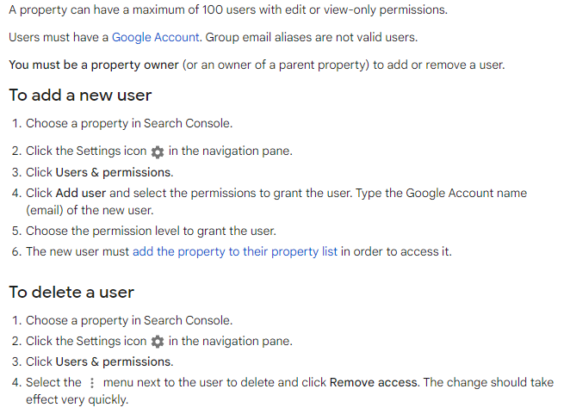
18. When you make an update to your webpage(s), open the URL Inspection tab and type in the domain of the site to be crawled again in search bar. You will select Request Indexing. 